RefReps
Step-by-Step

Logging in:
If you already have an account with RefReps, don’t create a new one. Use this link to go to the Log In page.
https://learn.refreps.com/login

If you have a RefReps account but need to connect to the CVOA organization, use this code to connect:
RRGLKNSQ

If you are new to RefReps, use this link to register and connect:
https://learn.refreps.com/join/b332dfab-e352-4018-ba2a-7500c195f6bc?method=link

After logging in, you see your dashboard with the course. In the actions, click on “continue course”.

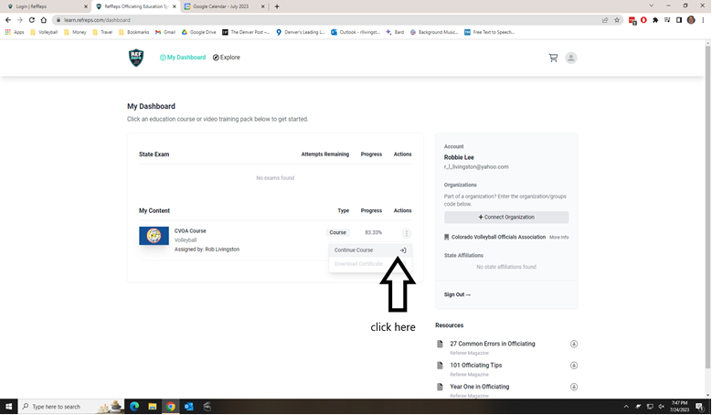

Then, on the left, you’ll see the navigation bar. Click where it says “Back to Modules”.

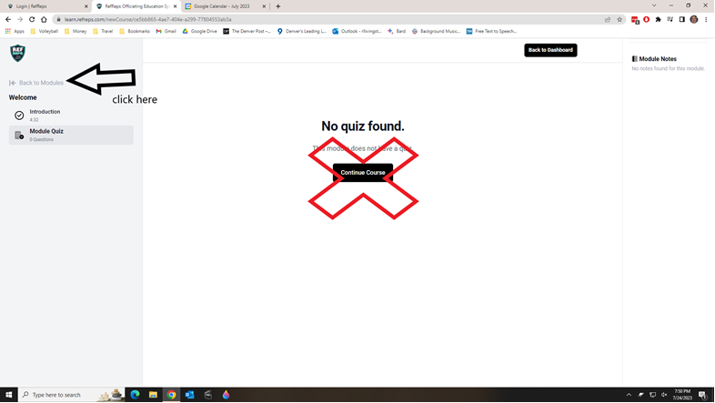

The Module list will be clickable for your next module. They say “optional” but disregard that.

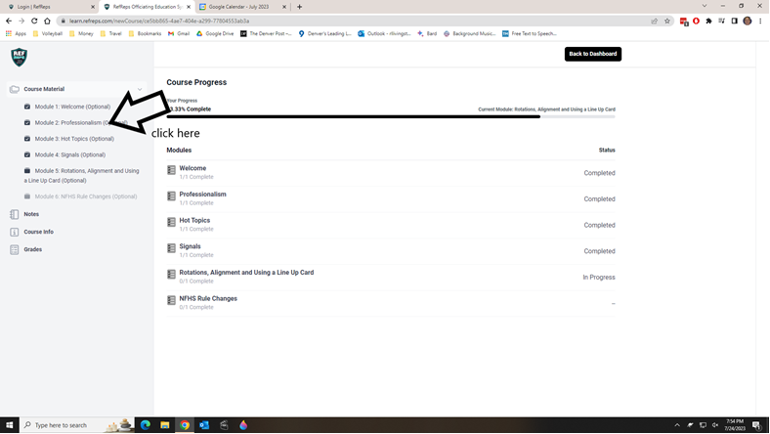

Continue in that fashion, clicking the “Back to Modules” link each time you complete a module and quiz.

When you have completed all of the modules, click on “Download Certificate” and you’re done!

