RefReps
Step-by-Step

Logging in:
- Use this link to log into RefReps, either as a new or returning user:
  - https://learn.refreps.com/join/b332dfab-e352-4018-ba2a-7500c195f6bc?method=link
- If you are new to RefReps, click on the “Create Account” link and fill out the form.
- If you have a RefReps account but need to connect to the CVOA organization, use this code to connect:
RRGLKNSQ
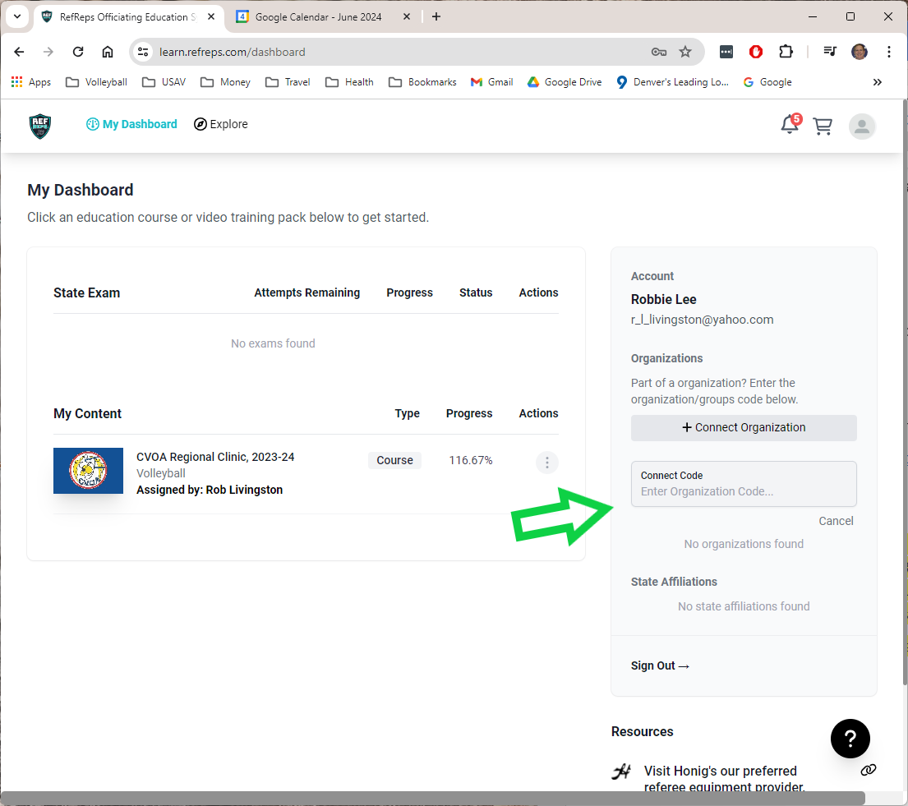
You may see last year’s 2023-24 Regional Clinic.
Do not try to open this, it is inactive.
After logging in for the first time this season, you may not immediately see the 2024-25 CVOA Regional Clinic. You must be manually added as a student of the course. Don’t panic. Send your area director a message and you will be added. Logging in will trigger the site admin to add you.
Log off now.

Navigating the RefReps site:

After logging back in, you see your dashboard with the Regional Clinic course. In the actions, click on “continue course”.

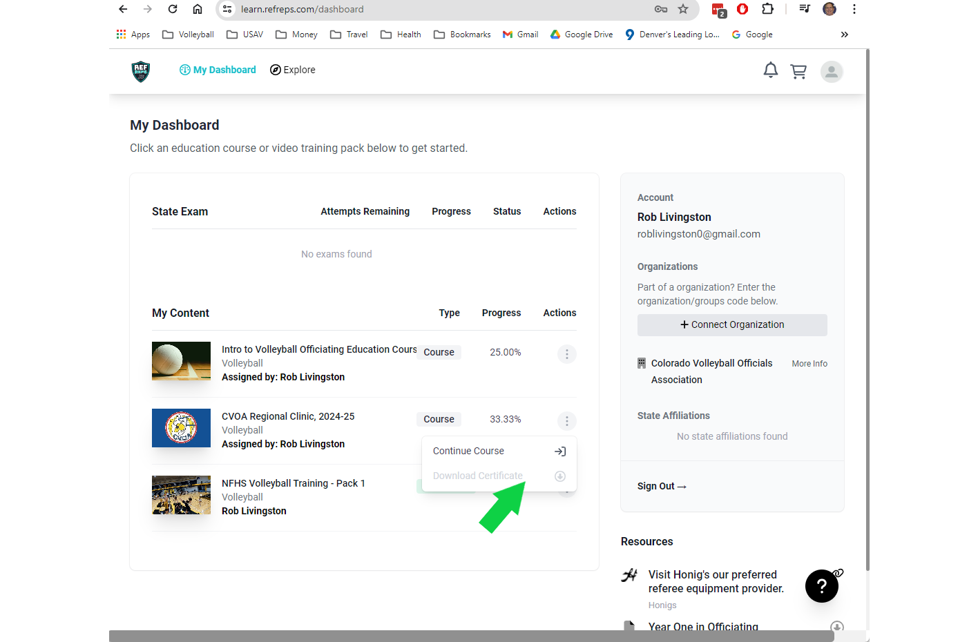

On the left is the navigation bar. Click on your next module to view. You must complete the current module and quiz in order to advance. You cannot skip ahead. Here you can see that the student is currently viewing Module 2.

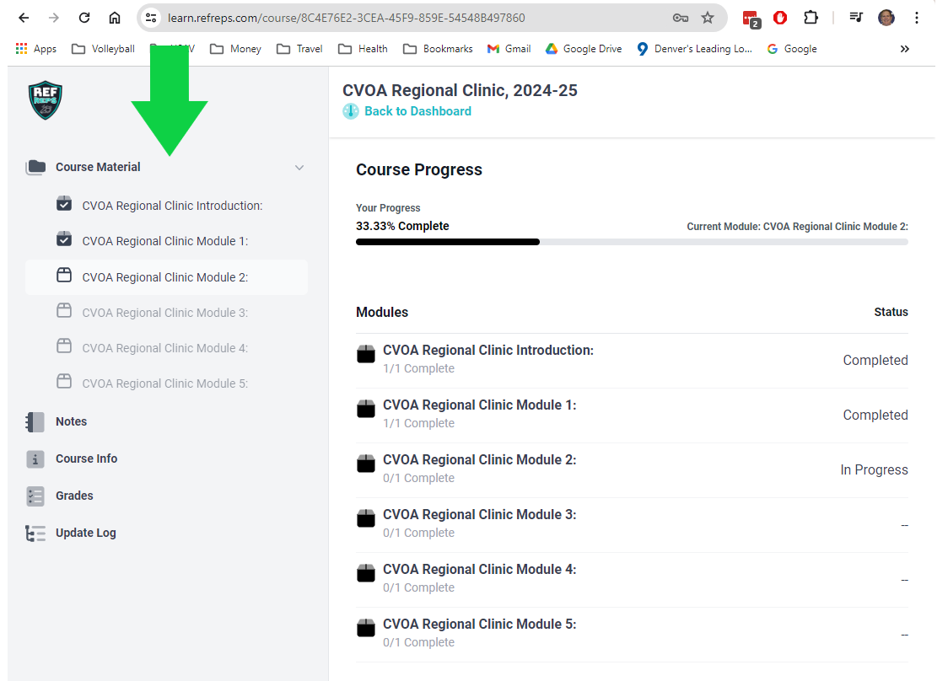

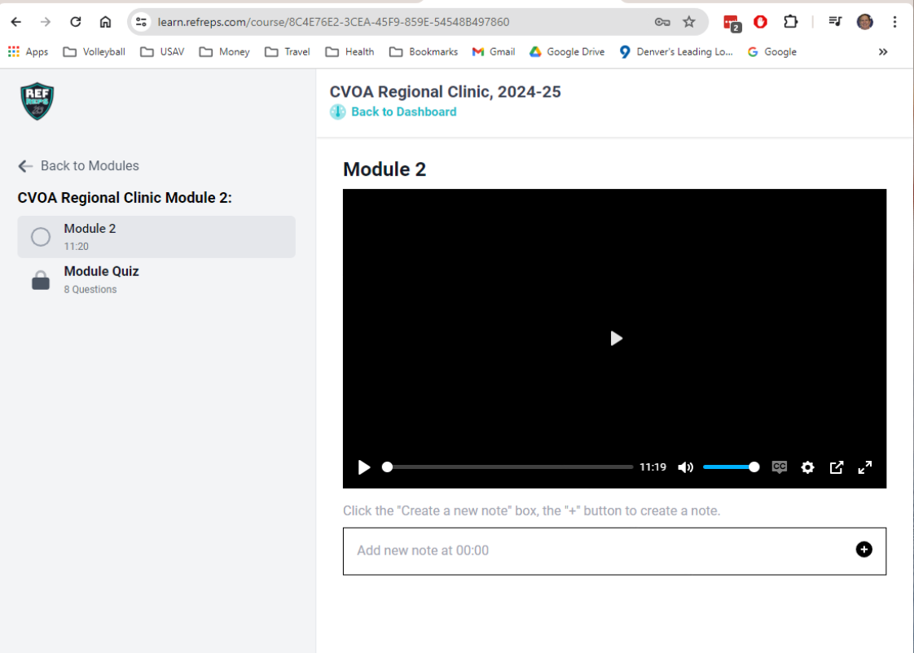
- If your internet bandwidth and speed isn’t the best in your area, you may encounter a “Buffering” message while viewing the videos. Just wait it out, it will load in time.

- Continue in that fashion, clicking the “Back to Modules” link each time you complete a module and quiz if it doesn’t automatically advance.

- You can log off and return to the course at any time, returning to the last completed section.

- When you have completed all of the modules, click on “Download Certificate” and you’re done!
