  VOLLEYBALL MANDATORY  SPORTSMANSHIP  PRE-MATCH PROCEDURE  SPORTSMANSHIP STATEMENT: As representatives of CVOA and CHSAA, we are here to promote sportsmanship and fair play. Let this competition reflect mutual respect among all participants and officials. Coaches, please certify that your players are legally equipped and uniformed according to NFHS rules. Good luck and have a great contest. | VOLLEYBALL MANDATORY  SPORTSMANSHIP  PRE-MATCH PROCEDURE  SPORTSMANSHIP STATEMENT: As representatives of CVOA and CHSAA, we are here to promote sportsmanship and fair play. Let this competition reflect mutual respect among all participants and officials. Coaches, please certify that your players are legally equipped and uniformed according to NFHS rules. Good luck and have a great contest.
  VOLLEYBALL MANDATORY  SPORTSMANSHIP  PRE-MATCH PROCEDURE  SPORTSMANSHIP STATEMENT: As representatives of CVOA and CHSAA, we are here to promote sportsmanship and fair play. Let this competition reflect mutual respect among all participants and officials. Coaches, please certify that your players are legally equipped and uniformed according to NFHS rules. Good luck and have a great contest. | VOLLEYBALL MANDATORY  SPORTSMANSHIP  PRE-MATCH PROCEDURE  SPORTSMANSHIP STATEMENT: As representatives of CVOA and CHSAA, we are here to promote sportsmanship and fair play. Let this competition reflect mutual respect among all participants and officials. Coaches, please certify that your players are legally equipped and uniformed according to NFHS rules. Good luck and have a great contest.
VOLLEYBALL MANDATORY  SPORTSMANSHIP  PRE-MATCH PROCEDURE  SPORTSMANSHIP STATEMENT: As representatives of CVOA and CHSAA, we are here to promote sportsmanship and fair play. Let this competition reflect mutual respect among all participants and officials. Coaches, please certify that your players are legally equipped and uniformed according to NFHS rules. Good luck and have a great contest. | VOLLEYBALL MANDATORY  SPORTSMANSHIP  PRE-MATCH PROCEDURE  SPORTSMANSHIP STATEMENT: As representatives of CVOA and CHSAA, we are here to promote sportsmanship and fair play. Let this competition reflect mutual respect among all participants and officials. Coaches, please certify that your players are legally equipped and uniformed according to NFHS rules. Good luck and have a great contest.
VOLLEYBALL MANDATORY  SPORTSMANSHIP  PRE-MATCH PROCEDURE  SPORTSMANSHIP STATEMENT: As representatives of CVOA and CHSAA, we are here to promote sportsmanship and fair play. Let this competition reflect mutual respect among all participants and officials. Coaches, please certify that your players are legally equipped and uniformed according to NFHS rules. Good luck and have a great contest. | VOLLEYBALL MANDATORY  SPORTSMANSHIP  PRE-MATCH PROCEDURE  SPORTSMANSHIP STATEMENT: As representatives of CVOA and CHSAA, we are here to promote sportsmanship and fair play. Let this competition reflect mutual respect among all participants and officials. Coaches, please certify that your players are legally equipped and uniformed according to NFHS rules. Good luck and have a great contest.
VOLLEYBALL MANDATORY  SPORTSMANSHIP  PRE-MATCH PROCEDURE  SPORTSMANSHIP STATEMENT: As representatives of CVOA and CHSAA, we are here to promote sportsmanship and fair play. Let this competition reflect mutual respect among all participants and officials. Coaches, please certify that your players are legally equipped and uniformed according to NFHS rules. Good luck and have a great contest. | VOLLEYBALL MANDATORY  SPORTSMANSHIP  PRE-MATCH PROCEDURE  SPORTSMANSHIP STATEMENT: As representatives of CVOA and CHSAA, we are here to promote sportsmanship and fair play. Let this competition reflect mutual respect among all participants and officials. Coaches, please certify that your players are legally equipped and uniformed according to NFHS rules. Good luck and have a great contest.
MATCH DATE _________________________  1st REFEREE _________________________  2nd REFEREE _________________________    https://chsaa.co/s/officials-eval  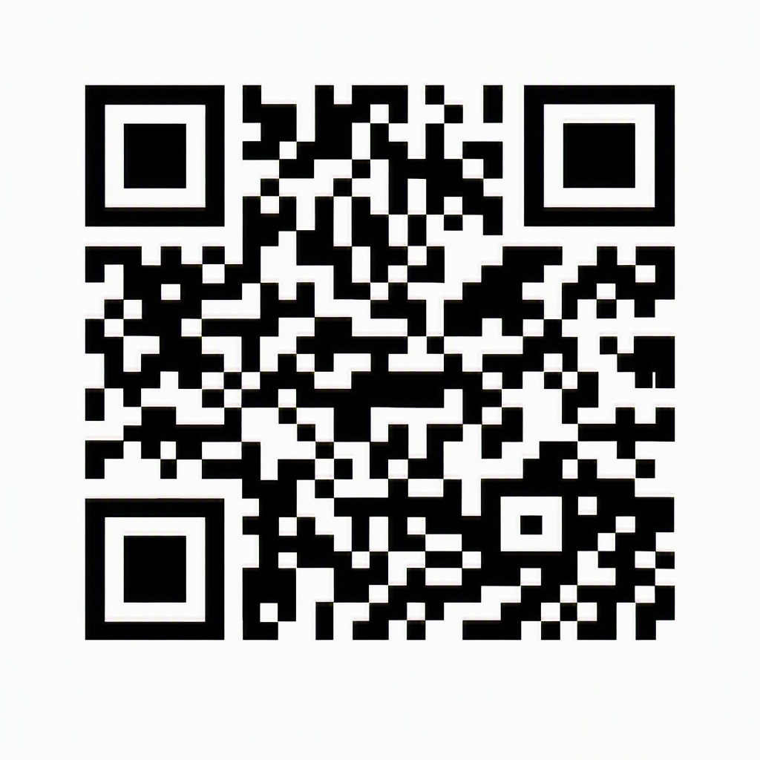 | MATCH DATE _________________________  1st REFEREE _________________________  2nd REFEREE _________________________  https://chsaa.co/s/officials-eval
MATCH DATE _________________________  1st REFEREE _________________________  2nd REFEREE _________________________  https://chsaa.co/s/officials-eval | MATCH DATE _________________________  1st REFEREE _________________________  2nd REFEREE _________________________  https://chsaa.co/s/officials-eval
MATCH DATE _________________________  1st REFEREE _________________________  2nd REFEREE _________________________  https://forms.chsaa.co/forms/rate-official | MATCH DATE _________________________  1st REFEREE _________________________  2nd REFEREE _________________________  https://chsaa.co/s/officials-eval
MATCH DATE _________________________  1st REFEREE _________________________  2nd REFEREE _________________________  https://chsaa.co/s/officials-eval | MATCH DATE _________________________  1st REFEREE _________________________  2nd REFEREE _________________________  https://chsaa.co/s/officials-eval
MATCH DATE _________________________  1st REFEREE _________________________  2nd REFEREE _________________________  https://chsaa.co/s/officials-eval | MATCH DATE _________________________  1st REFEREE _________________________  2nd REFEREE _________________________  https://chsaa.co/s/officials-eval

